Assignment 4.1 SQL Rossler Gian Karlo Boquiren

1. Build a query and save it as a view that displays all rentals, with the surname of the customer and of the employee who gave the film and the store to which the employee belongs, assigning- to each field a nickname.

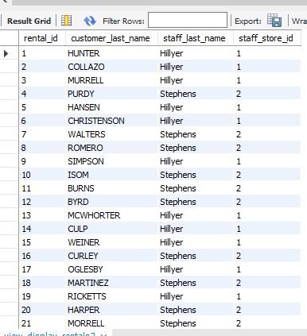

1. Then build another query that takes data from this view (so not from the original tables, thus use the nicknames) and joining it with table employees again, display also the surname of the responsible for the store, everything sorted by employee’s surname

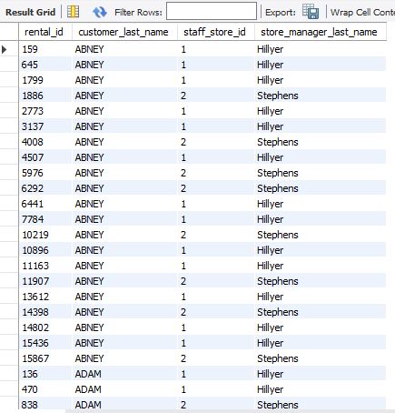

1. Generate a multicolumn index on the payment table that could be used by both

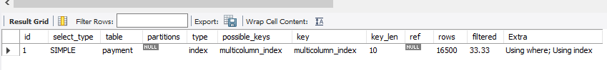

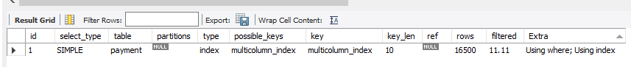

1. The film rental company manager would like to have a report that includes the name of every country, along with the total payments for all customers who live in each country. Generate a view definition that queries the country table and uses a scalar subquery to calculate a value for a column named tot_payments.

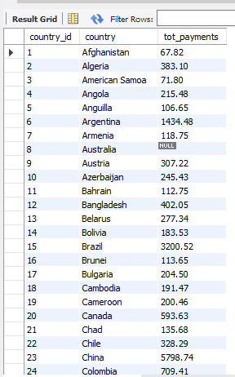

1. Write a query that lists all the indexes in the Sakila schema. Include the table names.  
     
   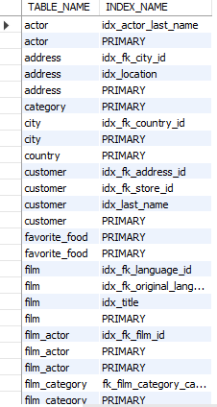
2. Write a query that generates output that can be used to create all of the indexes on the sakila.customer table. Output should be of the form:

"ALTER TABLE <table_name> ADD INDEX <index_name> (<column_list>)"

